Age 14+ Level
Worksheet 1
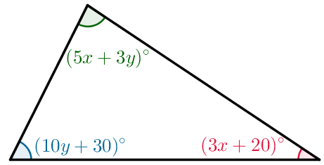
- Triangular Algebra
The interior angles of a triangle are $(5x+3y)°$, $(10y+30)°$ and $(3x+20)°$, where $x$ and $y$ are positive integers.
What is the value of $x + y$?

- Last-but-one
If all the integers from $1$ up to $n$ are multiplied together, this is called the factorial of $n$, and is written as $n!$.
For example, $4!=4×3×2×1=24$.

This means that the last-but-one digit of $4!$ is $2$.
What is the last-but-one digit of $99!$?

- Powerful Zeros
The number $3^{4}×4^{5}×5^{6}$ is written out in full.
How many zeros are there at the end of the number?

- Coin Collection
Tom has a collection of more than $24$ coins.
When he puts the coins in piles of $6$, there are $3$ coins remaining.
When he puts the coins in piles of $8$, there are $7$ coins remaining.

How many coins remain when he puts the coins in piles of $24$?

- Added Power
For how many primes $p$ is the number $p^{3}+3$ also prime?

- Square Sum
One of the following is the largest of nine consecutive positive integers whose sum is a perfect square. Which one is it?
a) 118 b) 128 c) 138 d) 148 e) 158

