Age 11+ Level
Worksheet 1
- Product 100
The product of four different positive integers is 100.
What is the sum of these four integers?
- Prime Order
How many of the three-digit numbers that can be made from all of the digits 1, 3 and 5 (used only once each) are prime?

- Producing Zeros
If the numbers 1, 2, 3, 4, 5, 6, 7, 8, 9, 10 are all multiplied together, how many zeros are there at the end of the answer?

- Almost a Million
Which of the following is divisible by 6?
(a) one million minus one
(b) one million minus two
(c) one million minus three
(d) one million minus four
(e) one million minus five
- Multiple Years
The year 2010 is one in which the sum of the digits is a factor of the year itself. What is the next year that has the same property?

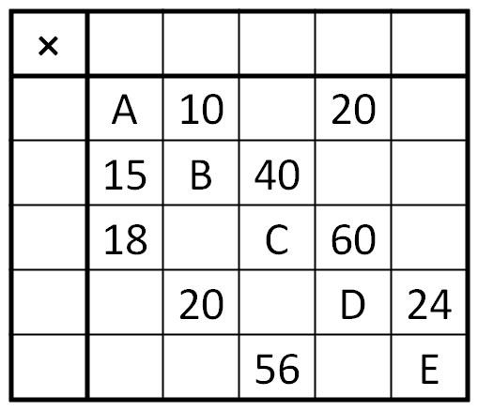
- Multiplication Table Puzzle
In the multiplication table on the right, the row and column headings are all missing, and only some of the products in the table are filled in.

All the numbers in the table are positive integers.
What is the value of $A+B+C+D+E$?

