Age 11+ Level
Worksheet 3

- Race Time
Frank and Gabriel competed in a 200m race. Gabriel finished in half a minute and Frank finished in one hundredth of an hour. Who won the race and by how many seconds?

- Three of a Kind
The time shown on a digital clock is 5:55.
How many minutes will pass before the clock next shows a time for which all the digits are the same?

- 24 Hour Conundrum
It is 225 minutes until midnight. What time is it on a 24-hour digital clock?
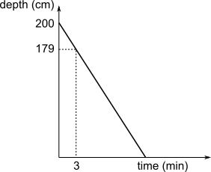
- Draining a Pool
Water is draining from a pool.
The graph shows the depth of the water, in centimetres, against time, in minutes.
At what time will the depth of the water be 144 cm?

- Eating Beans
The Bean family are very particular about beans. At every meal all Beans eat some beans. Pa Bean always eats more beans than Ma Bean but never eats more than half the beans. Ma Bean always eats the same number of beans as both children together and the two children always eat the same number of beans as each other.
At their last meal they ate 23 beans altogether. How many beans did Pa Bean eat?

- Brothers and Sisters
A boy has the same number of sisters as brothers.
Each of his sisters has only half as many sisters as brothers.
How many brothers and sisters are in the family altogether?

