Age 14+ Level
Worksheet 1
- How Many Digits?
How many digits are there in this product:

38 659 893 456 789 325 678 × 342 973 489 379 256?
- Pros and Cons
If $p$ is a positive integer and $q$ is a negative integer, which of the following is the greatest?

$p-q$ $q-p$ $p+q$ $-p-q$
- Sum Up
David listed ten consecutive numbers and removed one of them.
The sum of the remaining numbers was 2012.

Which number did he remove?
- Alberta’s Age
The digits of Alberta's age are interchanged, and then 1 is added to the total. The answer is half of Alberta's present age.

How old is Alberta?
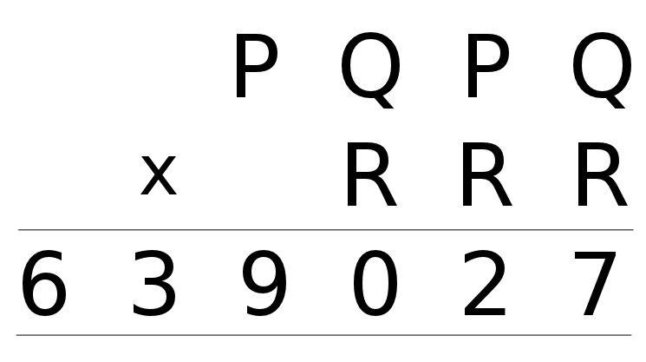
- Equal Length Powers
How many positive integers $n$ exist for which $n^{2}$ has the same number of digits as $n^{3}$?
- Repeat Product
What is the value of P+Q+R in this multiplication?

