Age 11+ Level
Worksheet 2
- Highs and Lows
I have a maximum/minimum thermometer in my greenhouse.
It records both the highest and the lowest temperatures reached from the time I reset it.

I reset it on Sunday when the temperature was $4℃$.
Overnight the temperature fell $5°$.
Then during Monday it rose by $6°$ before falling $10°$ during the night.
On Tuesday it rose by $4°$ and fell by $2°$ overnight.

What were the maximum and minimum temperatures recorded when I looked at the thermometer on Wednesday morning?

- Central Sum
In how many whole numbers between 100 and 999 is the middle digit equal to the sum of the other two digits?

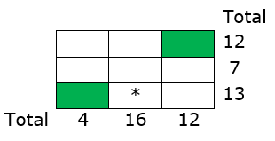
- Mini Kakuro
Use seven of the digits from 1 to 9 to fill in each unshaded square, so that no digit is repeated, and the totals of the entries in the rows and columns are as shown.

What number goes in the starred square?

- Reverse Ages
On Brian’s 14th birthday, his father was 41.
Brian noticed that his age was the reverse of his father's age.

How old will Brian be the next time his age is the reverse of his father's age?

- Count Back
What number is twenty-one less than sixty thousand?

