Age 11+ Level
Worksheet 1
- Mathematical Ages
Here are the dates of three pivotal female mathematicians:
Sophie Germain (French) 1776-1831
Sonja Kowalevsky (Russian) 1850-91
Emmy Noether (German) 1882-1935

Arrange them in order with the shortest-lived first.

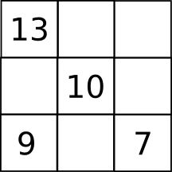
- Different Magic Square
In a magic square, the three numbers in each row, in each column, and in each diagonal add up to the same number.

Complete this magic square.

- Quiz Questions
A quiz has twenty questions with 7 points awarded for each correct answer, 2 points deducted for each wrong answer and 0 for each question omitted.

Jack scored 87 points.

How many questions did he omit?

- Debt Recovery
Tony owes Tina 40p.
Then Tina borrows 50p from Tony.
Later Tony gives Tina 60p.

Who has to pay what to whom to square things up?

- Loose Change
In how many ways can you give change for a ten pence piece?
(You can use 1p, 2p and 5p coins when giving change)

