Age 11+ Level

Worksheet 1

- The Square of My Age
If you add the square of Thom's age to Lauren's age the total is 62.
If you add the square of Lauren's age to Thom's age the total is 176.

How old are Thom and Lauren?

- Square Triangle
How many triangles have three angles that are all perfect squares, when measured in degrees?

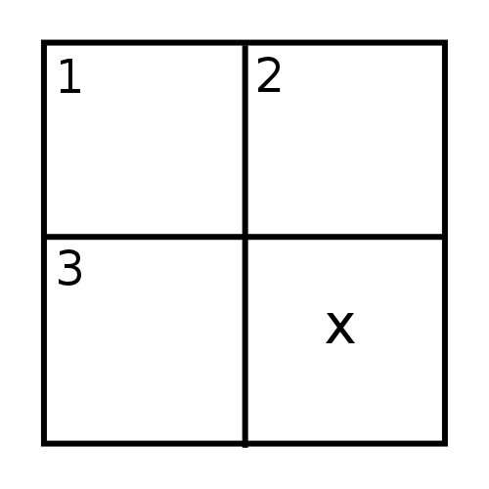
- Mini Cross-number
What is the digit x in this cross-number?
Across Down
1. A cube 1. One less than a cube
3. A cube 2. A number
- Tenth Power
Which of the following three statements are true?

a) $3^{10}$ is even
b) $3^{10}$ is odd
c) $3^{10}$ is a square number

- Age of Augustus
The English mathematician Augustus de Morgan, who died in $1871$, claimed that he became $x$ years old in the year $x^{2}$.
When was he born?

- Square Percentage
What percentage of the integers 1, 2, 3, ... 9999, 10000 are square numbers?

- Maundy Money
Every Maundy Thursday, the reigning monarch distributes 'Maundy money' to equal numbers of men and women.
One year at Newcastle 64 men and 64 women each received 64p, one penny for each year of the Queen's life.
Written as a power of 2, what was the total amount distributed in pence?

