Making bunting

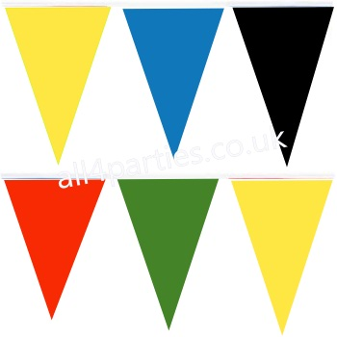
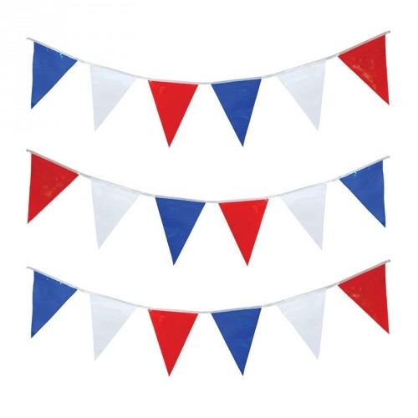

Sara and Dan want to make some bunting to hang up during the Jubilee and the Olympics.

They have been given some fabric squares in 6 colours:

red
white
blue
yellow
green
black

Each fabric square measures 100cm x 100cm.

They want to make bunting triangles that are 30cm long and 15cm wide.

- How many triangles can they cut out of each square? Sketch your answer.

- Will there be any fabric left over? What will be the dimensions of the left over pieces of fabric? Sketch your answer.

- The Jubilee bunting needs Red, White and Blue triangles.
The Olympic bunting needs Green, Yellow, Red, Black and Blue triangles.

- What is the maximum length of each type of bunting they can make?

- Will there be any triangles left over? How many of each colour will be left over?

