This game is about counting up to 100.
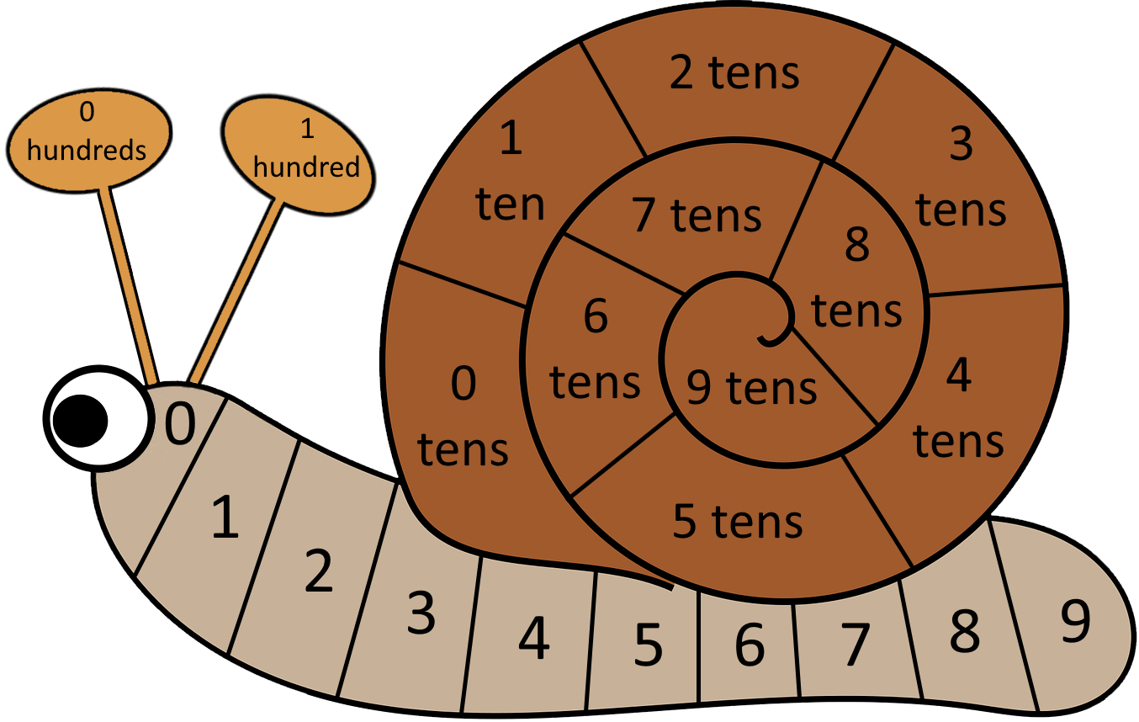
You will need the game board, an ordinary dice and three matching counters for each player.
How to play the game:
Start by putting one of your counters on '0', one on '0 tens' and one on '0 hundreds'.
The first player throws the dice and moves their counter that number of places along the snail's body. Take turns at throwing the dice.
After you get to '9', the first counter goes back to '0' and the second counter moves up to '1 ten'.
Keep moving the first counter along the snail's body and moving the second counter to the next 'ten' every time you get to the end and go from 9 to 0.
When your counter is on '9 tens' and needs to move, it can't move any further around the spiral. Instead, it goes back to '0 tens' and your third counter moves from '0 hundreds' to '1 hundred'. The first person to move their counter onto the '1 hundred' space is the winner!

