Cut out the statements and order them to show how to find the shaded area.

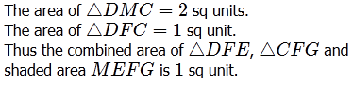 | A
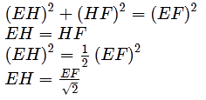 | B
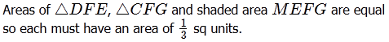 | C
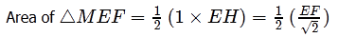 | D
 | E
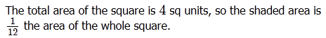 | F
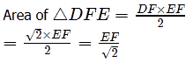 | G
 | H
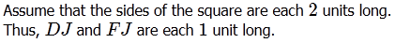 | I

