Rearrange the cards to explain how to find what fraction of the total area is shaded.
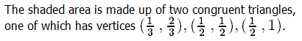 | A
 | B
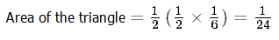 | C
 | D
 | E
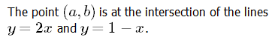 | F
 | G
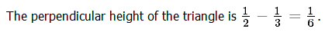 | H
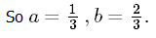 | I
 | J

