Here are some questions.
How would you represent them using:
- pictures?
- numbers?
- objects?
Can you think of any other ways of representing them?
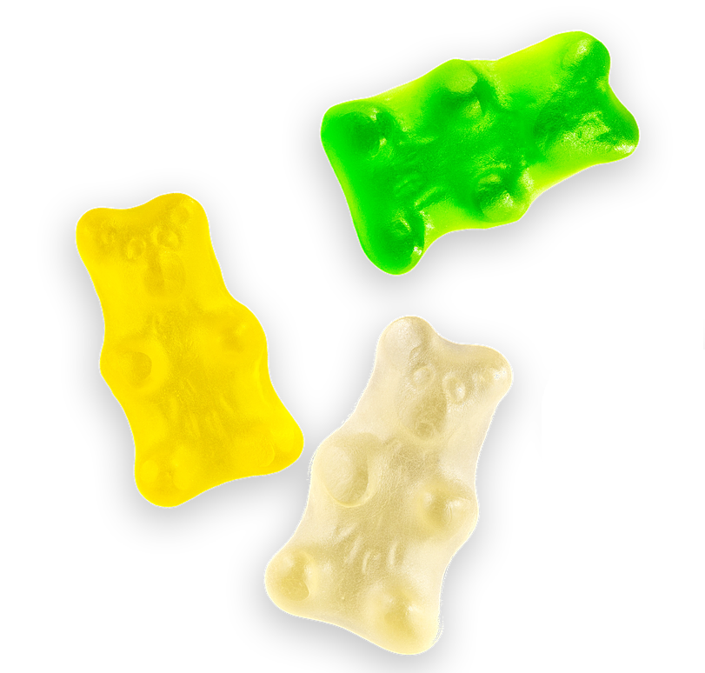 | Zoe had three sweets.  Her friend Ranjeet gave her two more.  How many sweets does Zoe have now?
Karala had 8 teddies.  She gave 3 of them to her little brother.  How many teddies has Karala got now? | 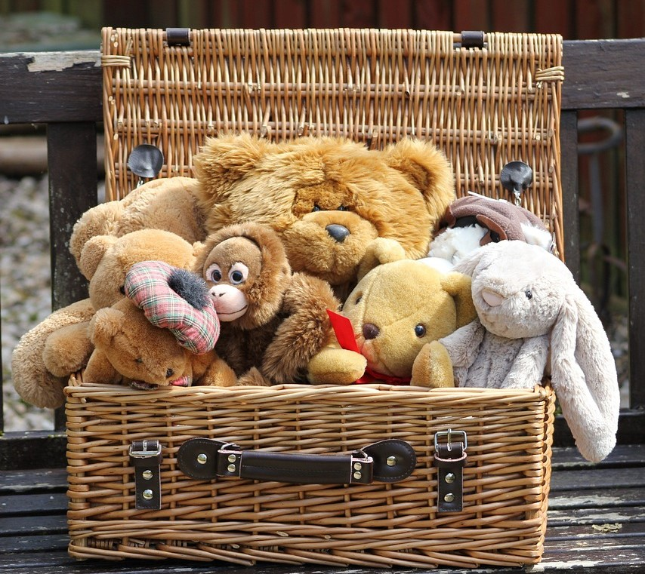
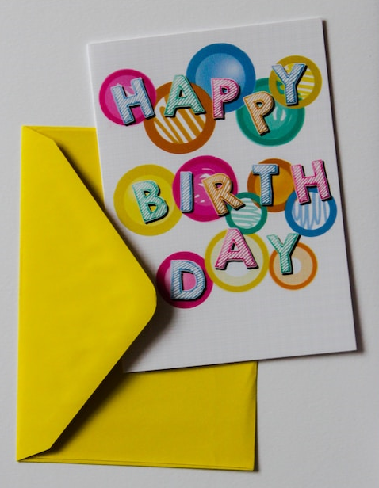 | It was Toby's birthday and he had 6 birthday cards.  Some more cards arrived in the post and then Toby had 9 cards.  How many cards arrived in the post?
Si had eight balloons.  Some popped and he only had five left.  How many popped? | 
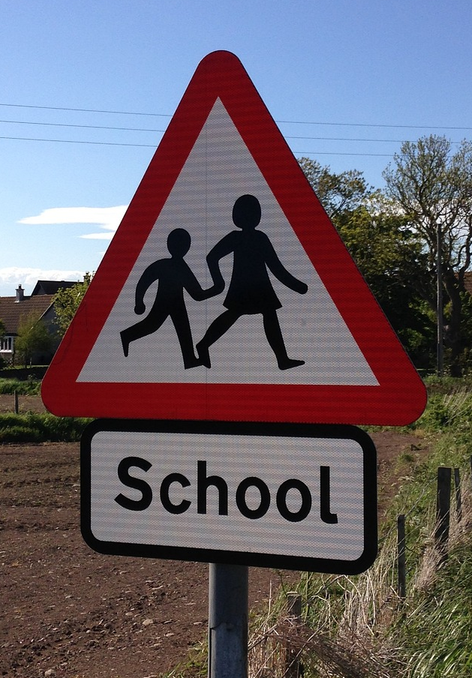 | Some children were walking to school.  Three more children joined them. Then there were nine children altogether.  How many were walking together at the beginning?
Marcus had some coins in his pocket.  Sadly he lost seven of them and now he only has three coins.  How many coins did he have before he lost some? | 