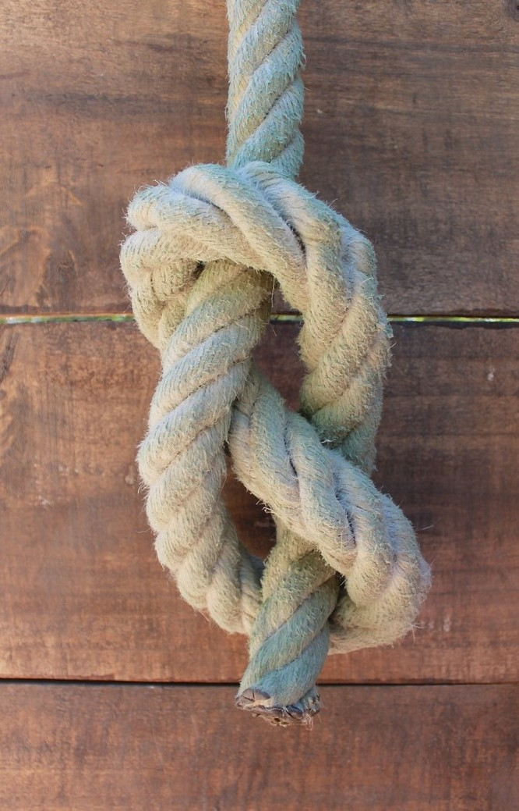
I wonder if you've ever used string or rope to make a knot, and then undone it afterwards. In this activity, we're going to look at undoing some maths that's been done.
To begin with, we're going to imagine taking a starting number and then doubling it. We want to undo the doubling by starting with just the answer and trying to get back to our starting number.
When I doubled my starting number, I got 6. How can I undo the doubling and get back to my starting number?

Suppose that I did this again with a new starting number, and when I doubled it I got 16. How can I undo the doubling?

How would you undo these three children's maths?
Danesh says: "I took 4 away. How can I get back to my starting number?"
Meg says: "I added 8. How can I get back to my starting number?"
Chris says: "I halved. How can I get back to my starting number?"
If these children all ended up with the number 12, what were their starting numbers?

