Look at these sets of bags similar to those in ‘What Numbers Can We Make?’
Investigate what numbers you can make when you choose three numbers from the bags. Once you think you know what is special about the numbers you can check your answer.
You can also find what is special when you choose four, five or six numbers.
When you have an efficient strategy, test it by choosing 99 or 100 numbers.
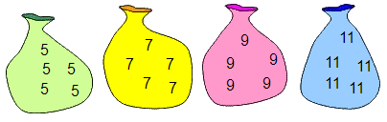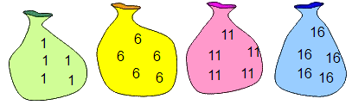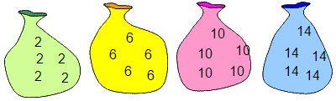
Set A
Set B
Set C
Can you explain your strategies?
And finally…
If the bags contained 3s, 7s, 11s and 15s, can you describe a quick way to check whether it is possible to choose 30 numbers that will add up to 412?

