How many dots?
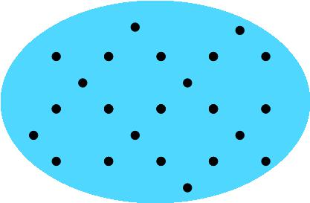
How did you count them?

What about your friends, how did each of them count the dots?

Ask your teacher for some other pictures of dots for you to count and share ideas about how you counted them.

