Now choose a couple of the patterns below.
Try to picture how to make the next, and the next, and the next...
Use this to help you find the number of squares, or lines, or perimeter, or dots needed for the 25th, 100th and n^{th} pattern.
Can you describe your reasoning?
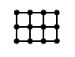
Growing rectangles
This rectangle has height 2 and width 3.

Work out the perimeter, the number of dots, and the number of lines needed to draw a rectangle with:
- height 2 and width 25
- height 2 and width 100
- height 2 and width n
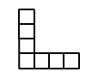
L Shapes
This L shape has height 4 and width 4.

Work out the perimeter, the number of squares, and the number of lines needed to draw an L shape with:
- height 25 and width 25
- height 100 and width 100
- height n and width n
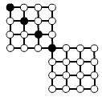
Two squares
This pattern with two squares has four black dots.

Work out the number of white dots and the number of lines needed to draw a pattern with:
- 25 black dots
- 100 black dots
- n black dots

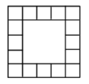
Square of Squares
This pattern has side length 5.

Work out the number of edge squares and the number of lines needed to draw the pattern with:
- side length 25
- side length 100
- side length n
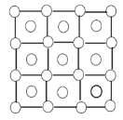
Dots and More Dots
This pattern has side length 3.

Work out the number of dots and the number of lines needed to draw the pattern with:
- side length 25
- side length 100
- side length n
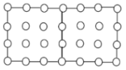
Rectangle of Dots
This pattern is made from two joined squares with side length 3.

Work out the number of lines and the number of dots needed to draw the pattern of two joined squares with:
- side length 25
- side length 100
- side length n

