
Choose any two odd numbers, such as 5 and 9. Add them together.
Draw a picture or make a model to show how the numbers add together.
What do you notice?
Once you’ve done that, have a look on the next page to see the models and pictures that some other children have made.

Adam found some dominoes with 5 and 9 spots on them:
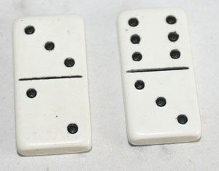
Sarai made a model using Multilink cubes:
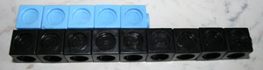
Abdul drew a picture of 5 add 9 like this:
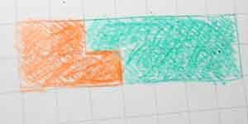
What do you notice about the answer?
Look closely at the models and pictures.
Can you see anything in any of them that would work in exactly the same way if you used two different odd numbers?
Can you use your one example to prove what will happen every time you add any two odd numbers?
See if you can explain this to someone else. Are they convinced by your argument?
Once you can convince someone else, see if you can find a way to show your argument. You might draw something or take a photo of things you have used to prove that your result is always true from your example.

