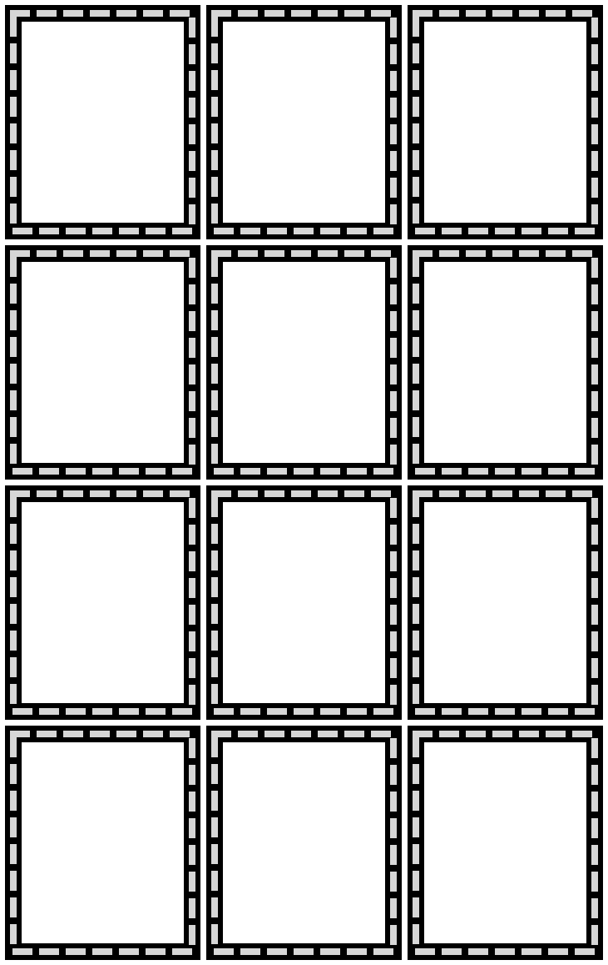
14

$-$2
18

$-$3
21

÷3
5

×2
15

÷3
8

$-$5
10

×2
20

+1
4

×2
12

÷3
3

×6
7

×2

