In the video at nrich.maths.org/8054, Alison works out the sum of the first twenty terms of the sequence:

2, 8, 32, 128, 512 …

Here are two shots from the video:

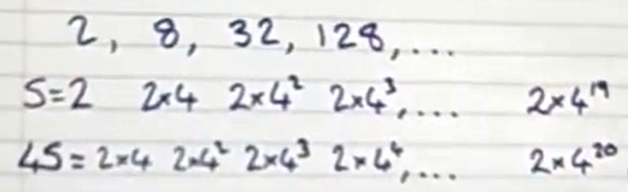

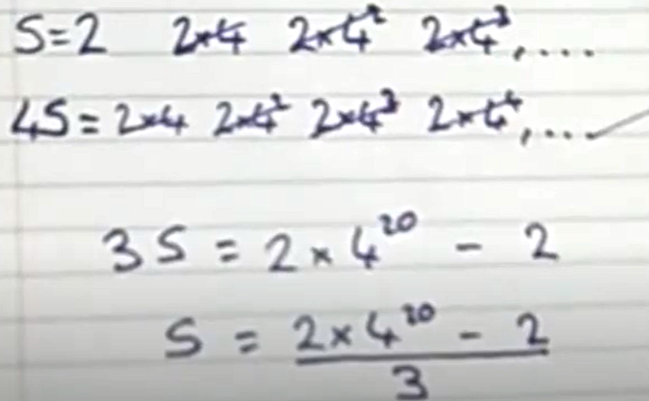

Can you adapt Alison's method to sum the following sequences?
- 3, 9, 27, 81, 243, … up to the 15th term
- 5, 10, 20, 40, 80, … up to the 12th term
- $\sum_{i=1}^{20}{}\left(3×2^{i-1}\right)$
- $\frac{1}{2}, \frac{1}{4}, \frac{1}{8}, \frac{1}{16},$… up to the 10th term
Can you find an expression for the following sum up to the nth term?
$a, ar, ar^{2}, ar^{3},$…

