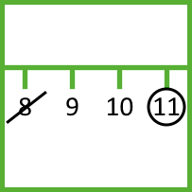

This game starts with a 0 to 20 number line.
Player 1 picks two numbers, crosses them out and circles either their sum or their difference. The crossed out numbers can’t be used again.
Player 2 crosses out the circled number and another number, and again circles either their sum or their difference.
The winner is the person who stops their opponent from being able to take a turn!
Instead of playing against each other, you could work together to use as many numbers as possible. Can you use all the numbers from 0-20? Why or why not?
nrich.maths.org
Strike it Out

