On the table in front of you is a grid like this:
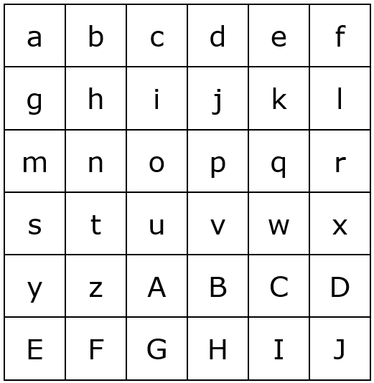
Each of the letters stands for a different number. The numbers go up in size from the top left to the bottom right, so 'a' is smaller than 'b', 'b' is smaller than 'c', etc. But the numbers might not be consecutive and they might not be going up by the same amount each time, so the first line could be something like this:
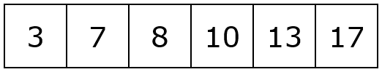
Imagine that you have another version of this grid (with the same numbers), but this one is made of plastic that you can see through. You place the plastic one over the other grid so that it covers it completely. You can flip it over and/or turn it around as you put it down. Now, each pair of numbers (one above the other) is multiplied together, and all of these products are added together.
Your challenge is to say which way of flipping over and/or turning the plastic grid will give you the highest total and which way will give you the lowest total.

