Here are the dimensions of nine cuboids. You may have these dimensions as a set of cards. The challenge is to arrange them in a 3 by 3 grid like the one on the right.
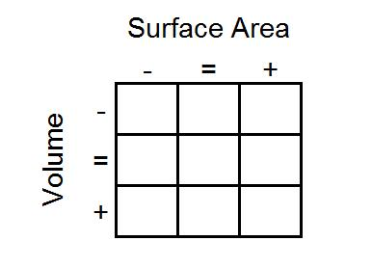
1 by 2 by 28  cuboid | 4 by 4 by 4  cube | 2 by 4 by 7  cuboid
1 by 2 by 26  cuboid | 2 by 4 by 6  cuboid | 4 by 5 by 6  cuboid
4 by 5 by 7  cuboid | 1 by 2 by 24  cuboid | 1 by 4 by 14  cuboid

As you go from left to right, the surface area of the shapes must increase.
As you go from top to bottom, the volume of the shapes must increase.
All the shapes in the middle column must have the same surface area.
All the shapes on the middle row must have the same volume.
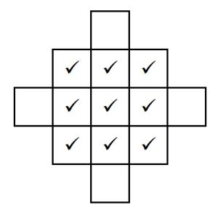
What reasoning can you use to help you to decide where each cuboid must go?
Once you've placed the nine cards, look at the extended grid below:
The ticks represent the nine cards you've already placed.
Can you create cards with dimensions for cuboids that could go in the four blank spaces that satisfy the same criteria?

Can you design a set of cards of your own with a different cuboid in the centre?

