Here are nine shapes. You may have these shapes as a set of cards.
The challenge is to arrange the shapes in a 3 by 3 grid like the one on the right.
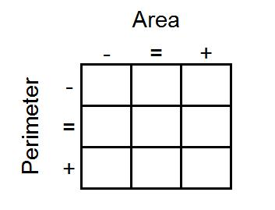
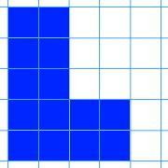 | 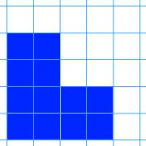 | 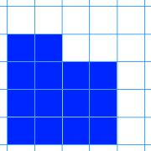
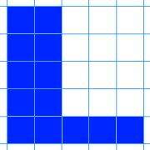 | 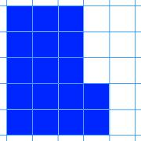 | 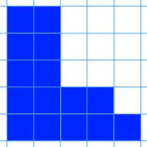
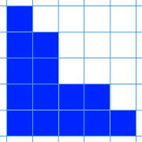 | 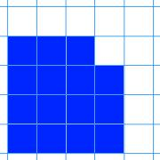 | 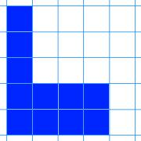

2 by 8 rectangle | 4 by 4 square | 1 by 15 rectangle
5 by 5 square | 3 by 8 rectangle | 2 by 7 rectangle
1 by 16 rectangle | 3 by 6 rectangle | 1 by 9 rectangle
As you go from left to right, the area of the shapes must increase.
As you go from top to bottom, the perimeter of the shapes must increase.
All the shapes in the middle column must have the same area.
All the shapes on the middle row must have the same perimeter.
Here are the dimensions of nine rectangles. You may have these dimensions as a set of cards.

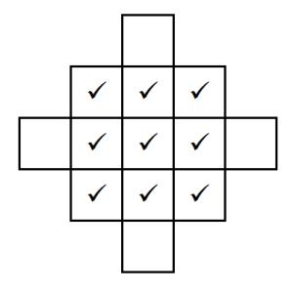
Can you arrange them in the grid in the same way?
Once you've placed the nine cards, look at the extended grid below:
The ticks represent the nine cards you've already placed.
Can you create cards with dimensions for rectangles that could go in the four blank spaces that satisfy the same criteria?
Not all the spaces are possible to fill. Can you explain why?
Can you produce a set of cards that could be arranged in the same way, if the card in the centre is a 1 by 5 rectangle?

