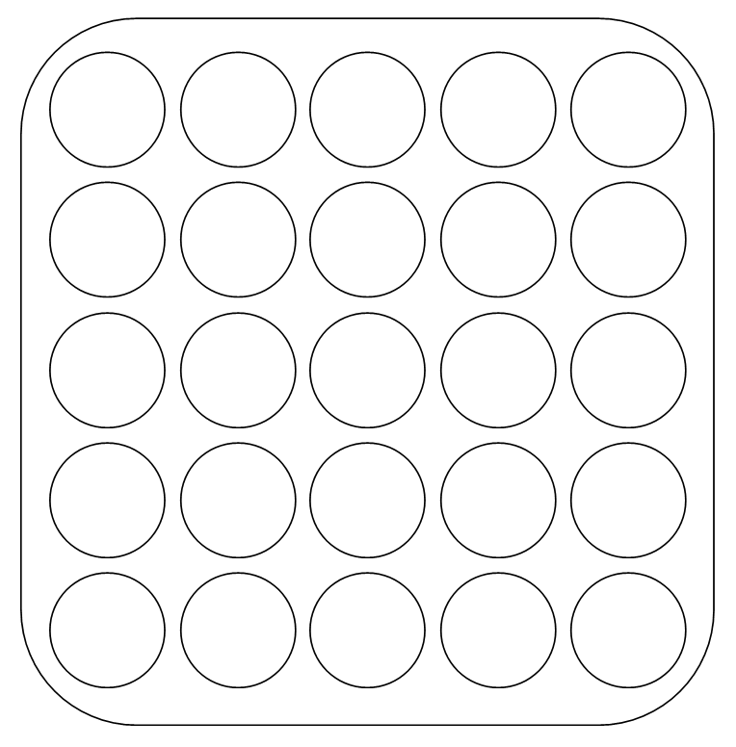The aim of this challenge is to completely fill the grid with counters.
You will need 25 counters or buttons (or anything else that you have), a 1-6 dice, pencil and paper.
Throw the dice and place that number of counters anywhere on the grid.
Repeat this over and over again.
Each time you throw the dice, make a record (for example by keeping a tally) so that you know how many times you have thrown it so far.
Continue until you have completely filled the grid.
Make a note of the total number of throws that it took to fill the grid.
How many throws did it take to fill the grid completely?
Have some more goes to see if you can do it in fewer throws of the dice.
What is the smallest number of throws you did it in?
Do you think it would be possible to complete the grid in even fewer throws if you kept on trying? Why or why not?

There are two more versions of this challenge:
Version 2
In this version, you have to place the counters from a throw in the same row.
Version 3
In this version, you still have to place the counters from a throw in the same row, but now you have to completely fill the top row before you can place any counters in the second row, and so on throughout the grid.

Have lots of goes at these versions of the challenge.
How many throws did it take to complete the grid each time?

Which version of the challenge needed the fewest number of moves? Will that always be the case, do you think? Why?

