Imagine a cone sitting on its point being filled with water:

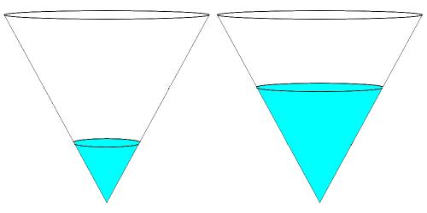

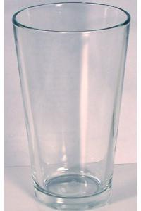
In the second picture, the height of the water level has doubled. How has the volume of water changed?
What if the height had trebled?
What if the height had increased by a factor of ^{n}?
How would I need to increase the height in order to double the volume?
How would I need to increase the height in order to treble the volume?
How would I need to increase the height in order to increase the volume by a factor of ^{n}?
What would a graph of volume (y) against height (x) look like?
What would a graph of height (y) against volume (x) look like?
Now consider this pint glass. It is not a whole cone, it is a frustum (a cone with its point cut off).

How could you use the graph for a cone to work out what the graph for the Pint Glass would look like?
Extension challenge
Using a similar analysis, can you work out the shape of the graph for height against volume for a cone sitting on its base rather than its point?
Can you use your graph to work out what the graph for the Conical Flask would look like?
Very challenging extension:
Can you work out an analytical form (equation) for the function linking volume and height for a spherical flask?

