This activity can be done alone or with a friend. The aim is to get to the end of the track in as few jumps as possible.
Here is the track of squares that you will be jumping on:
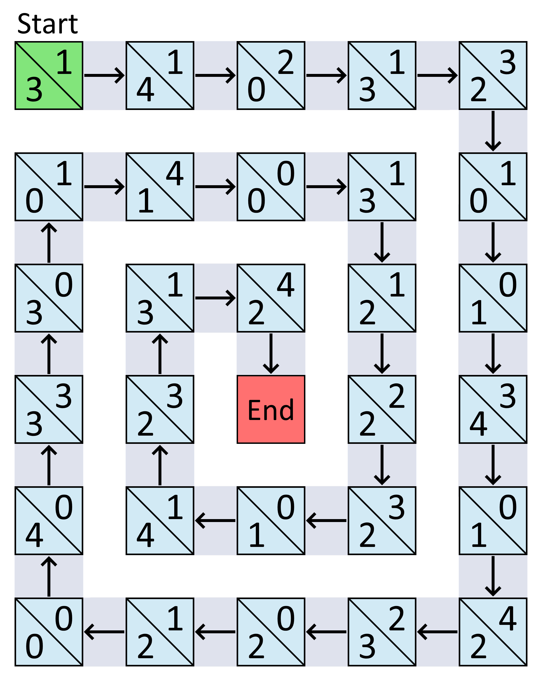
The numbers on each square are the numbers of squares that you can jump forwards or backwards when you are on that square. On the 'Start' square, you can jump forwards 1 or 3 squares for your first jump. If you land on a square with 1 and 4 on it, you can jump forwards or backwards either 1 or 4 squares.
If the square has 0 and 0 on it, you can't jump at all. You have to go right back to the beginning and start again!
Have a few tries at getting from the green square to the red square by making these jumps. How could you count the number of jumps you are making?
What is the least number of jumps you can make to get round the whole track? Which squares do you need to land on?

