 | 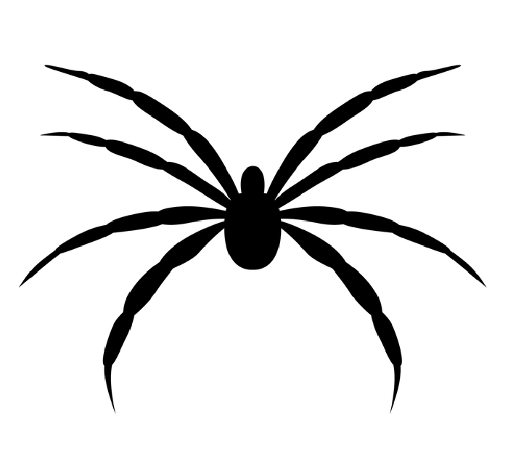 | 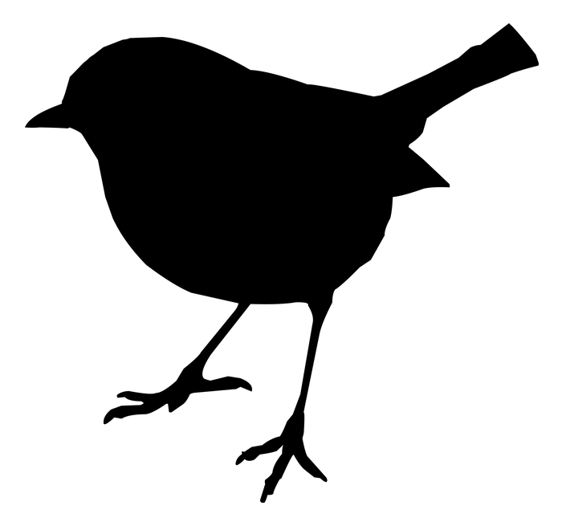
 | 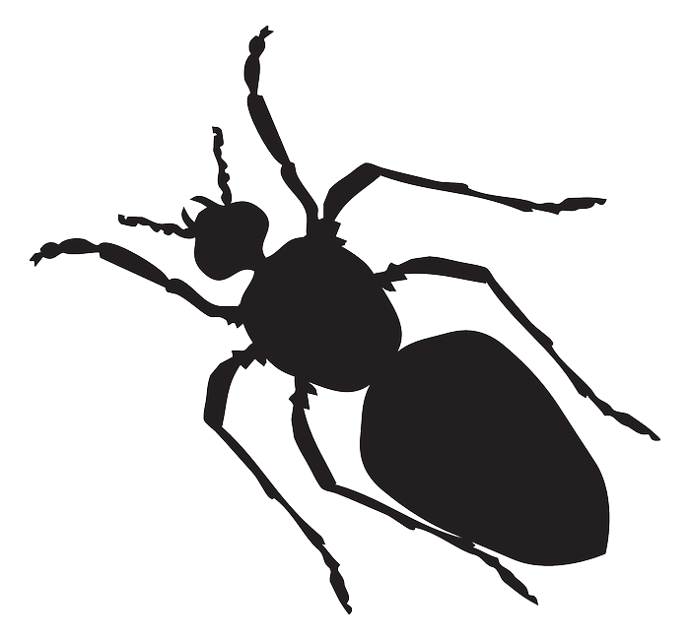 | 
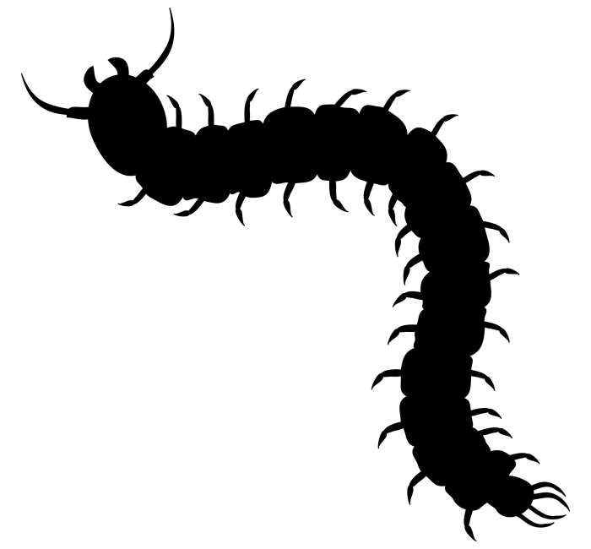 | 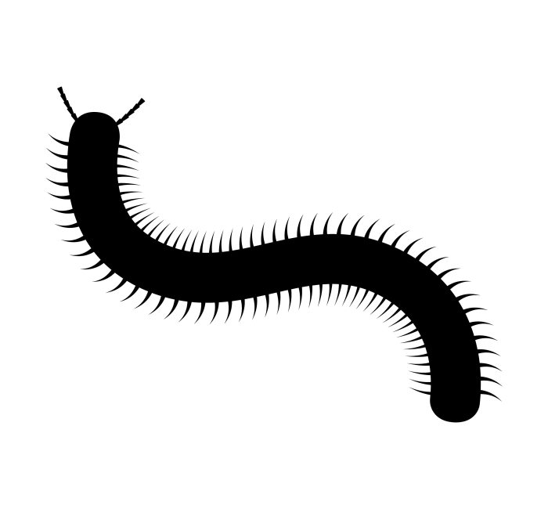
No legs | 1 pair of legs | 2 pairs of legs
3 pairs of legs | 4 pairs of legs | 5 pairs of legs
About 15 pairs of legs | Between 18 and 200 pairs of legs
Cat | Spider | Bird
Snake | Ant | Crab
Centipede | Millipede

