Charlie likes to go for walks around a square park.
Here is a diagram of the journey he took one day:
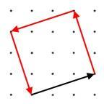
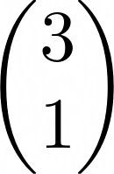
He started his journey by walking along the black vector

What vectors did he need to walk along to complete his journey?

Draw some other square parks that Charlie could walk around, and find the vectors that would describe his journey.
Can you describe and explain any relationships between the vectors that determine Charlie's journey around any square park?
Alison likes to walk across parks diagonally.

One day, she walked along the blue vector

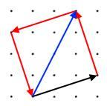

For the parks you drew above, find the vectors that would describe Alison's diagonal path.
- Can you describe any relationships between the vectors that determine Alison's and Charlie's journey, for any square park?
- Given the vector that describes Alison's journey, how can you work out the first stage of Charlie's journey?
- If all square parks have their vertices on points of a dotty grid, what can you say about the vectors that describe Alison's diagonal journey?
Can you explain and justify your findings?

