This activity challenges you to decide on the ‘best’ number to use in each of the following statements.
You may like to talk to someone else about what you’re thinking. You may need to do some estimating, some calculating and some research.
Please send us your solutions and don't forget to explain how you arrived at your conclusions.
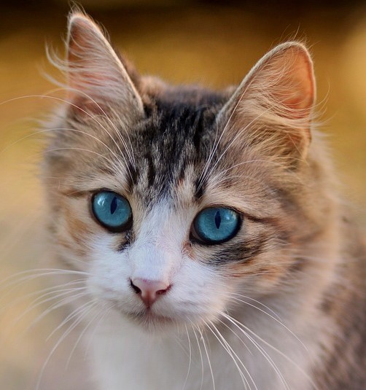
1) There are roughly 10/500/1000 million domestic cats in the world.
2) On average, cats weigh 1.5/4.5/8 kg.
3) Domestic cats sleep on average 8−9/13−14/18−19 hours a day.
4) There are roughly 600/800/1000 million domestic dogs in the world.
5) The average life of a dog is 10−14/14−18/18−20 years.
6) Dolphins live in groups called pods or schools of up to 12/20/30 individuals.
7) Adult elephants need to drink about 100/200/400 litres of water a day.
8) A giraffe's neck is about 120/170/220 cm long.
9) A giraffe's tail hair is 2/5/10 times as thick as the average human hair.
10) On average, male lions weigh 180/250/330 kg.
11) A lion's roar can be heard 8/12/16 kms away.
12) On average, lions rest for 10/15/20 hours a day.

