
When Spain played Belgium in the preliminary round of the men's hockey competition in the 2008 Olympics, the final score was 4 - 2.

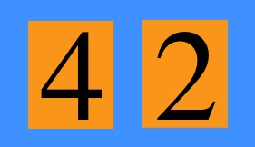
What could the half time score have been?
Can you find all the possible half time scores?
How will you make sure you don't miss any out?
In the final of the men's hockey in the 2000 Olympics, the Netherlands played Korea. The final score was a draw: it was 3 - 3 and they had to take penalties.

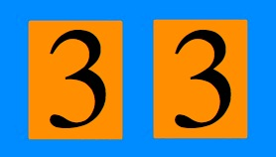
Can you find all the possible half time scores for this match?

