Imagine you had four bags containing a large number of 1s, 4s, 7s and 10s.

You can choose numbers from the bags and add them to make different totals. You don't have to use numbers from every bag, and there will always be as many of each number as you need.

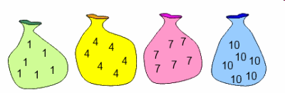

Choose some sets of 3 numbers and add them together.
What is special about your answers?
Can you explain what you've noticed?

What if you choose sets of 4 numbers and add them together?
What if you choose sets of 5 numbers, 6 numbers, 7 numbers...?
What totals do you think it would be possible to make if you choose 99 numbers? Or 100 numbers?

