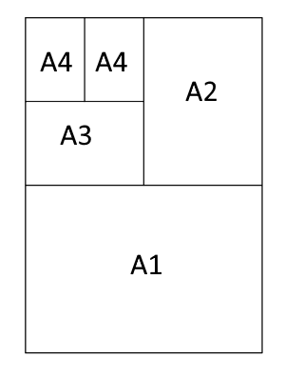
You may be familiar with the standard paper size A4.
Two sheets of A4 fit together to make a sheet of A3, two sheets of A3 fit together to make a sheet of A2, and so on.
Each member of the A paper size family is an enlargement of the others - they are all similar shapes.
Can you work out the ratio of the shorter to the longer side of a piece of A paper?
A sheet of A0 has an area of 1 square metre.
Can you use this fact to deduce the length and width of the different A paper sizes?
On a photocopier, approximately what percentage would you need to scale by in order to photocopy an A3 poster onto A4 paper?
Here are some challenging questions to consider:
Can you find a consistent way to define A(-1) and other negative paper sizes?
Can you find a consistent way to define A$\left(1/2\right)$, and other fractional paper sizes?

