I can generally work it out by doing this:
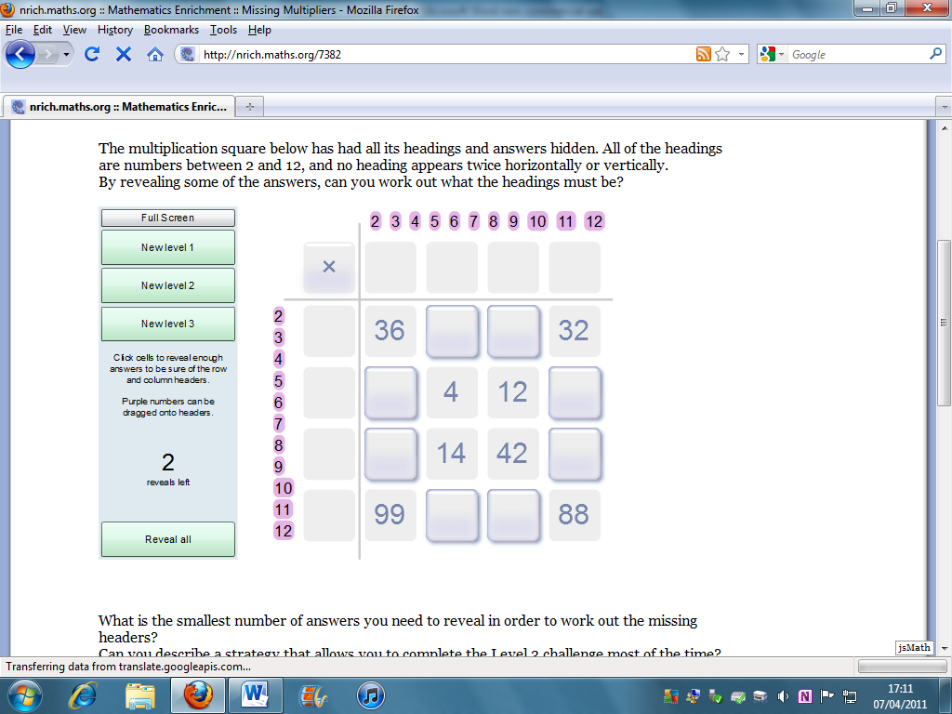
For example, along the top row, 36 and 32 are both multiples of 4 (They’re also multiples of 2, but 36 is 18 times 2, and the maximum allowed is 12). This means that the top row has multiples of 4.
From that, I can work out the column headings above them. The top left should be 9, therefore, since the bottom left number is 99, the heading on the bottom row must be 11.
You then hit a dead end, but start again in the middle with 4 and 12, which are both multiples of 2 and 4, or 14 and 42 which are both multiples of 7. It’s best to start with the latter, and we know that row heading must be 7. Eventually, you can work the whole thing out.
