Here are pictures of the five Platonic Solids - solids made from just one type of polygon with the same number of polygons meeting at each vertex.

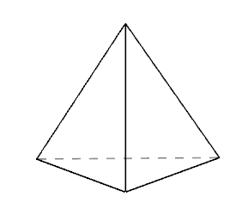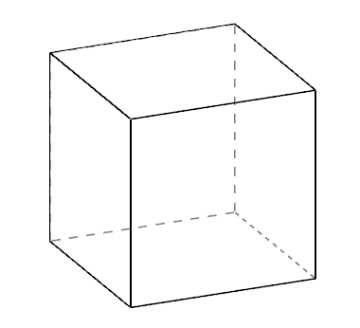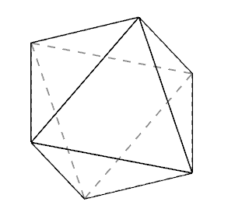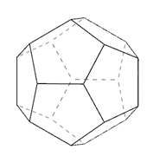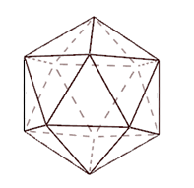

Can you convince yourself that there are no more?
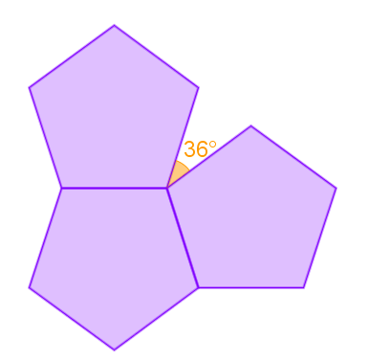

The angle deficit at a vertex of a polyhedron is a measure of how far short each angle sum is from 360º.

For example, in a dodecahedron, three pentagons with interior angles of 108º meet at each vertex, so the angle sum is 324º and the angle deficit is 36º:

Can you work out the angle deficit at the vertices of the other Platonic solids?

The total angle deficit is the sum of the deficits at each vertex.
What do you notice about the total angle deficit for the Platonic solids?

