Archimedean Solids have two properties:

- They are formed by two or more types of regular polygons, each with the same side length
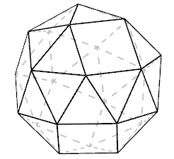
- Each vertex has the same pattern of polygons around it.

Here is a picture of an Archimedean Solid with 24 vertices.

Its vertex form {3, 3, 3, 3, 4} is defined by the polygons that meet at each vertex: triangle, triangle, triangle, triangle, square.

Calculate the total angle deficit for this solid.
Does it match your observations about the Platonic solids?

Try to suggest some other vertex forms which might give rise to Archimedean solids, assuming all solids share the property you have discovered. If you have access to construction sets such as Polydron, you could test out your ideas.
Below are some vertex forms you might like to try: some of them give rise to solids and some of them don't. Can you decide which will work before testing them out?

{3, 8, 8}
{4, 5, 8}
{3, 8, 10}
{3, 4, 3, 4}
{5, 3, 3, 4}
{6, 3, 4, 3}
{3, 3, 3, 3, 5}

