What can you say about these two shapes?


What is the area of each one? What is the perimeter of each one?

What can you say about the shapes below?
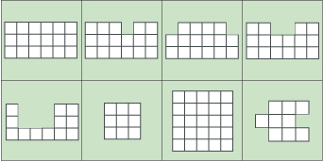

Can you draw a shape in which the area is numerically equal to its perimeter? And another?
Can you draw a shape in which the perimeter is numerically twice the area?
Can you draw a shape in which the area is numerically twice the perimeter?
Can you make the area of your shape go up but the perimeter go down?
Can you make the perimeter of your shape go up but the area go down?
Can you draw some shapes that have the same area but different perimeters?
Can you draw some shapes that have the same perimeter but different areas?

