Take a pack of cards and remove the Jacks, Queens and Kings.
Shuffle the remaining cards, and then lay the whole pack face up on the table in a snake, like this one:
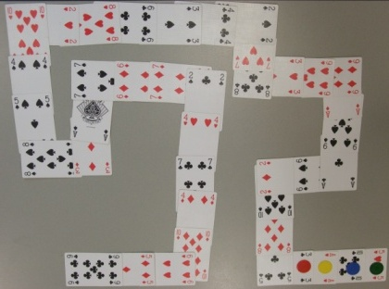
Place four different coloured counters on the first four cards in the snake. Then move each counter foward the number shown on its card (Aces count as 1). Keep moving each counter until it can't go any further without going off the end.
Did your counters all finish on different cards?
Repeat the experiment a few times.
How often did all the counters finish on different cards?
How often did they all finish on the same card?
Can you explain your results?
Challenge
Find a way to arrange the cards so that all four counters finish on different cards.
Can you do the same with five counters?

