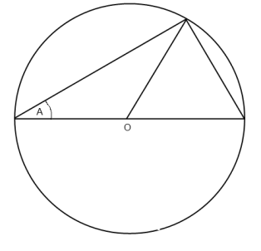
In this diagram O is the centre of a unit circle (i.e. a circle with radius 1).
Use it to find two trigonometrical relationships between A and 2A.

Here are another two diagrams so that you can try out some ideas. You might like to draw some extra lines on the diagrams.

