Take a look at the image below.
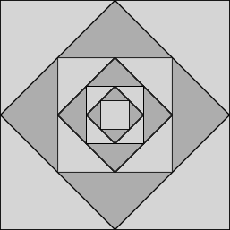

How do you think the pattern was made?
How do you think the pattern would continue?

What proportion of the total area of the square is taken up by the small square in the middle?
How do you know?
Imagine continuing the pattern towards the centre of the square.
If this process could be continued forever, what proportion of the image would be coloured dark grey?
Try to provide a convincing explanation that your answer is right.
Below is a collection of images created using repeating processes.

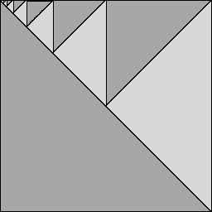
Choose a few of the images below, and work out what fraction of the total is taken up by the five largest dark grey shapes.
Add your fractions to estimate the proportion of the total that is coloured blue.
If each process could be continued for ever, what proportion of the whole image would be coloured dark grey?
