The diagrams below show circles with 9 equally spaced points on the edge, and one in the centre.
Each circle has a triangle on it, which uses the centre dot and two of the dots on the edge.
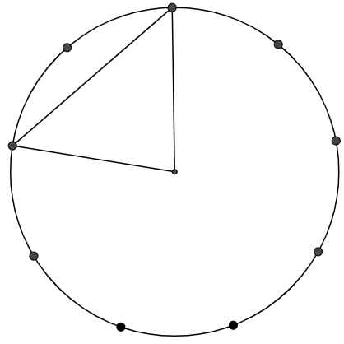
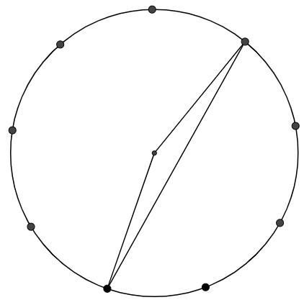
Can you work out the angles in these triangles?
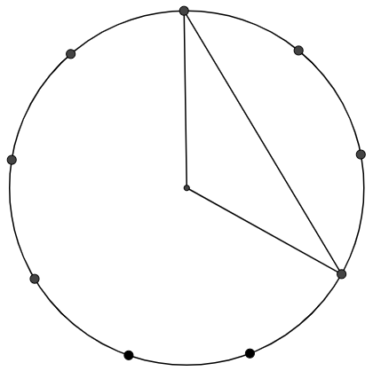
Draw some more triangles on 9-dot circles, by joining the centre dot and two dots on the edge. Can you work out the angles in your triangles?
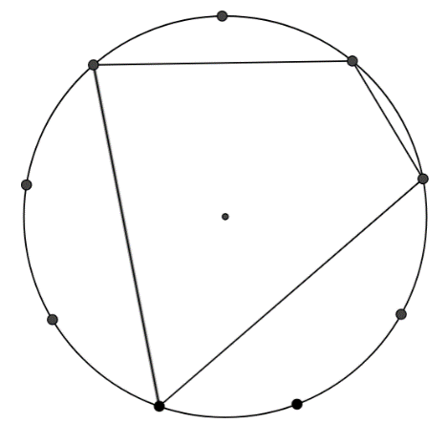
Below is a quadrilateral whose interior contains the centre of the circle, by joining four dots on the edge.
Can you work out the angles in this quadrilateral?

Draw some more quadrilaterals whose interior contains the centre of the circle, by joining four dots on the edge of a 9-dot circle. Can you work out the angles of your quadrilaterals?

What do you notice about the angles on opposite vertices of your quadrilaterals?
Does this only happen with 9 dot circles?
You may wish to explore the opposite angles of quadrilaterals on circles with a different number of dots.

Extension:
Will the same happen if you draw a circle and choose four points at random to form a quadrilateral?

