I took the graph $y=4x+7$ and performed the four transformations shown on the cards below.

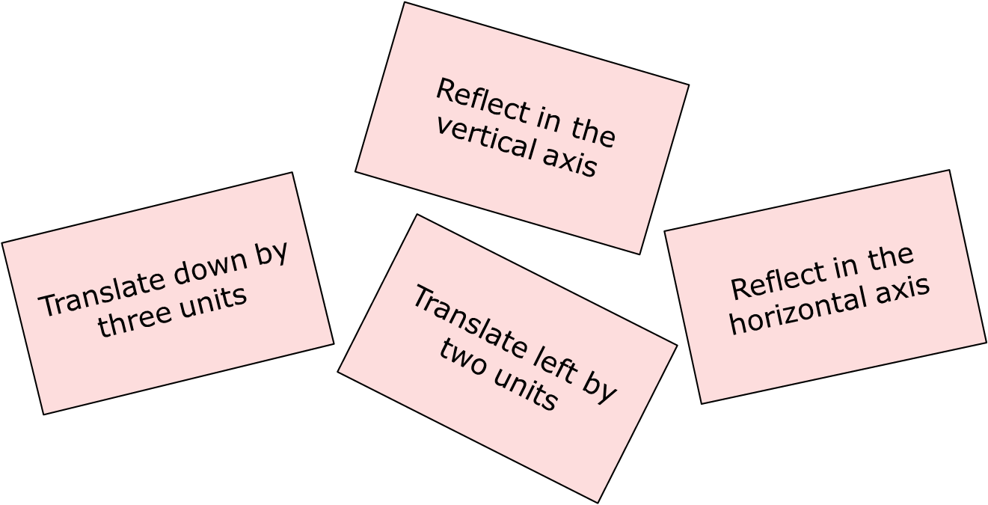

Unfortunately, I can't remember the order in which I carried out the four transformations, but I know that I ended up with the graph of $y=4x-2$.

Can you find an order in which I could have carried out the transformations?
There is more than one way of doing this - can you find them all?
Can you explain why different orders can lead to the same outcome?

What other lines could I have ended up with if I had performed the four transformations in a different order?

