Unit fractions (fractions which have numerators of 1) can be written as the sum of two different unit fractions.
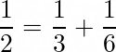
For example,

Charlie thought he'd spotted a rule and made up some more examples.
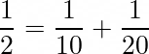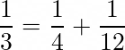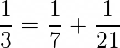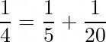
Can you describe Charlie’s rule?

Are all his examples correct?
What do you notice about the sums that are correct?

Find some more correct examples.
How would you explain to Charlie how to generate lots of correct examples?

Alison started playing around with and was surprised to find that there wasn't just one way of doing this.
She found:

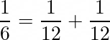
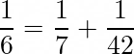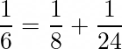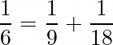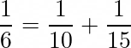

(BUT she realised this one didn't count because they were not different.)

Charlie tried to do the same with .. Can you finish Charlie’s calculations to see which ones work?
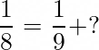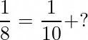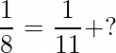

Can all unit fractions be made in more than one way like this?

Choose different unit fractions of your own to test out your theories.

