I'm finding it hard to draw perpendicular lines. Here are my best efforts so far but I don't think they're quite right!
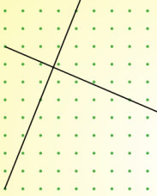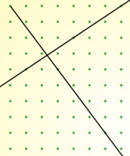

I know that the sides of a square are at right angles, so if I learn to draw tilted squares I may be able to find an efficient method for drawing perpendicular lines.
Experiment on the dotty grids on the next page until you can draw tilted squares with confidence.
Work out the gradients of the lines which form your squares.
Is there a relationship between the gradients of perpendicular lines?
Can you use your relationship to explain why the two sets of lines above are not perpendicular?

Here are some pairs of coordinates which can be joined to make straight lines.
Decide whether the two lines are perpendicular or not, and explain how you know.
Can you decide without plotting the points?

First line |  |  |  |  |  |  |  |  | Second line
Through (6,9) and (10,1) |  |  |  |  |  |  |  |  | Through (4,2) and (14,7)
Through (6,8) and (21,12) |  |  |  |  |  |  |  |  | Through (1,4) and (5,14)
Through (-3,-2) and (-1,1) |  |  |  |  |  |  |  |  | Through (6,1) and (15,-5)



