Consider these solids:
- A sphere of radius 1cm
- A solid cylinder with height 4/3 cm and radius 1cm
- A solid circular cone with base radius 1cm and height 4cm
- A solid cylinder of height 4/9 cm with a hole drilled through it, having an annular (ring-shaped) cross-section with internal radius 1cm and external radius 2cm.

Can you sketch what each solid would look like?
Can you work out the volume of each solid?

Experiments are conducted where a solid is chosen and has a string firmly attached at a fixed point. The solid is then lowered at a rate of 1cm per minute into a beaker of water and the height of displaced water is measured.

The results are measured on the following chart:
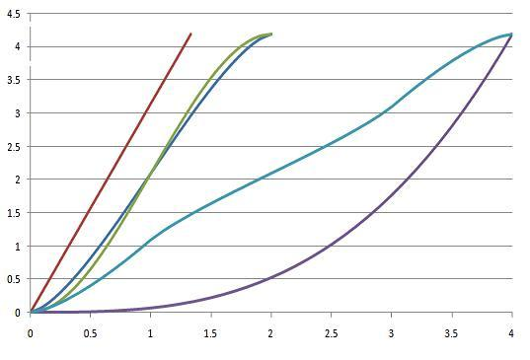
Can you work out what the two axes represent?
Can you work out which curve corresponds to which solid and in which orientation it is lowered into the beaker? (Note: One solid is used twice, in two different orientations).
Could you sketch the curve for the same solids in other orientations? What about different solids?
Extension task: Can you find equations which represent the volumes of the immersed parts of the solids? They vary in difficulty. If you cannot find the equation explicitly, can you describe clearly what needs to be found?

