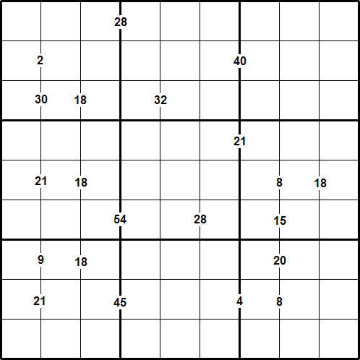

Rules of Multiples Sudoku
Like a conventional Sudoku, this Multiples Sudoku has two basic rules:
- Each column, row, and 3 x 3 subgrid must have the numbers 1 to 9.
- No column, row, or subgrid can have two cells with the same number.

The puzzle can be solved with the help of the numbers which are placed on the border lines between selected pairs of neighbouring cells.
These numbers are the product of the two digits in the cells to the left and right of the clue.
For example, where there is a 12 on the line between two neighbouring cells, the cells must contain 2 and 6, or 6 and 2, or 3 and 4, or 4 and 3.
After finding the values of all the unknown digits, the puzzle is solved by the usual sudoku strategy.

