A series of vessels of uniform cross section look like letters when viewed face-on. They are 1 cm thick, and the corners of the vessels have either whole or half cm values for their coordinates.

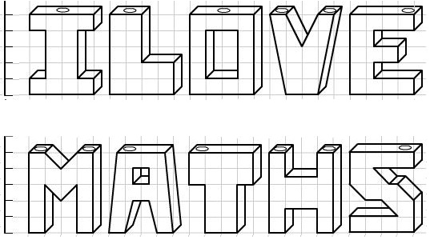
Water is poured slowly into each vessel through one of the holes at the top at a rate of 1 cm³ per minute.
Seven of these vessels take the same time to fill up. Which are they?
The height of the pool of water in one of the vessels is measured and a chart of the height against time is plotted, as follows:
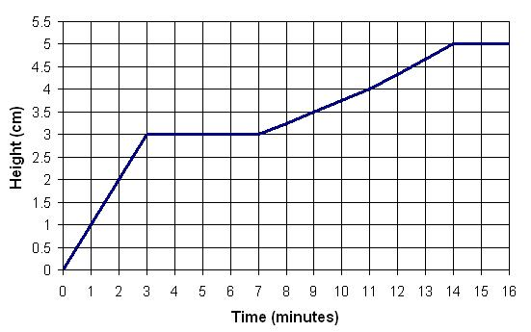
Which vessel does this chart correspond to? Can you explain what each part of the chart corresponds to?

Can you make charts of height against time for some of the other letters?

