Take a piece of paper.
Fold it along the long axis and then open it up.
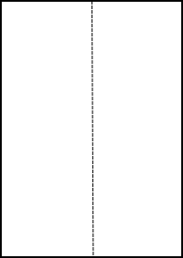

Now fold one corner over and onto the centre crease so that the fold line passes through the corner next to it (on the short side of the paper).
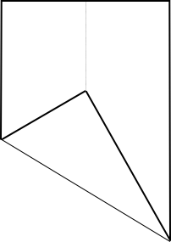

You have created some angles. There are angles of 60° and of 30°. Can you prove this?
Does the paper have to be A4?

