You have a set of the digits from 0-9.

Can you arrange these digits in the five boxes below to make two-digit numbers as close to the targets as possible? You may use each digit once only.
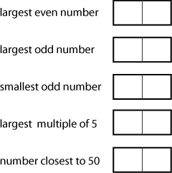
How will you know that your solution is as close to the targets as possible?
Try out some ideas. Can you find other ways of doing it?

