You have two sets of the digits from 0 to 9.

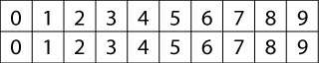

The idea is to arrange these digits in the five boxes to make four-digit numbers as close to the target number as possible.
You may use each digit once only.

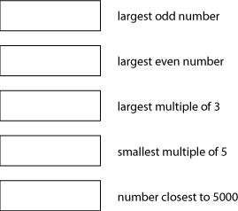
Try out some ideas. Can you find other ways of doing it?

