We have two fair spinners each numbered 1, 2, 3, 4.

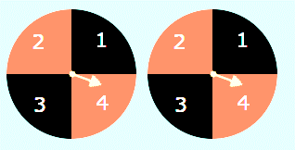
We're going to spin them both and add the numbers.
What possible totals might you get?
What is the least likely/most likely total to occur?
Can you summarise your ideas clearly? Can you justify them?
You could use the interactivity at http.nrich.maths.org/6033 to test these hypotheses.
Now make a new set of spinners, and write down a hypothesis about the possible outcomes and the shape of the relative frequency bar chart.

Justify your ideas to a friend. You could test them by using the interactivity at http.nrich.maths.org/6033 .

